Your official referendum booklet

VOTING IS COMPULSORY

About this booklet
This official referendum booklet contains two important documents: Your official Yes/No referendum pamphlet, and Your official guide to the 2023 referendum.
Your official Yes/No referendum pamphlet includes:
- What may change in the Constitution; and
- The Yes and No cases.
The Yes/No cases were provided by the majority of members of Parliament who voted for or against the proposed law and who desired to forward such a case.
The AEC does not have legislative authority to amend or fact check the Yes or No cases.
Your official guide to the 2023 referendum contains important information about voting and polling places, and a message from the Electoral Commissioner.
The official guide was written by the Australian Electoral Commission.

Alternative versions of this booklet
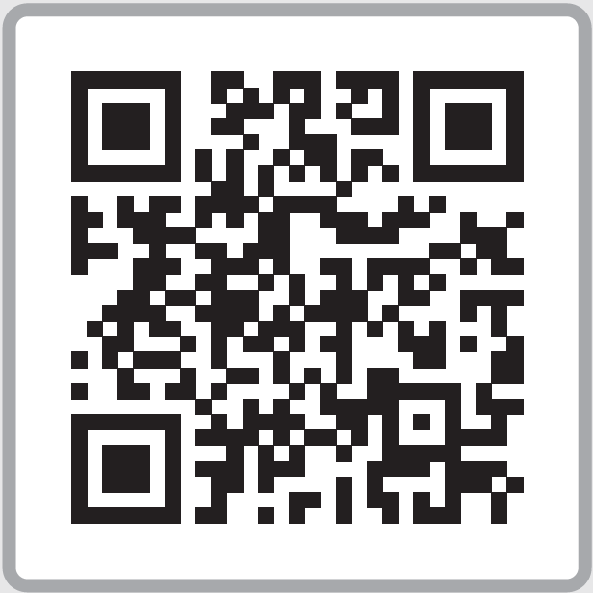
Your official referendum booklet will be available in other languages and accessible formats progressively throughout September on the AEC website at aec.gov.au/translatedbooklet

Translated versions

First Nations languages
Your official referendum booklet is available in First Nations languages as audio tracks.

Culturally and linguistically diverse languages
Your official referendum booklet is available in culturally and linguistically diverse languages as written translations.

Accessible formats

Blind and low vision
Your official referendum booklet is available on the website in large print, e-text and audio files. These formats, as well as Braille, can also be requested by calling 13 23 26.

Easy Read
Your official guide to the 2023 referendum is available in Easy Read for voters with different reading abilities.
For information about voting and the referendum in other languages call the number listed next to your preferred language.
Arabic: 1300 720 132
Burmese: 1300 290 617
Cantonese: 1300 720 135
Croatian: 1300 720 136
Dari: 1300 290 618
Farsi (Persian): 1300 290 619
Greek: 1300 720 137
Italian: 1300 720 138
Khmer: 1300 720 134
Korean: 1300 720 468
Macedonian: 1300 720 139
Mandarin: 1300 720 142
Polish: 1300 720 143
Portuguese: 1300 720 145
Russian: 1300 720 146
Serbian: 1300 720 147
Spanish: 1300 720 148
Turkish: 1300 720 149
Vietnamese: 1300 720 152
Other languages: 1300 720 153

